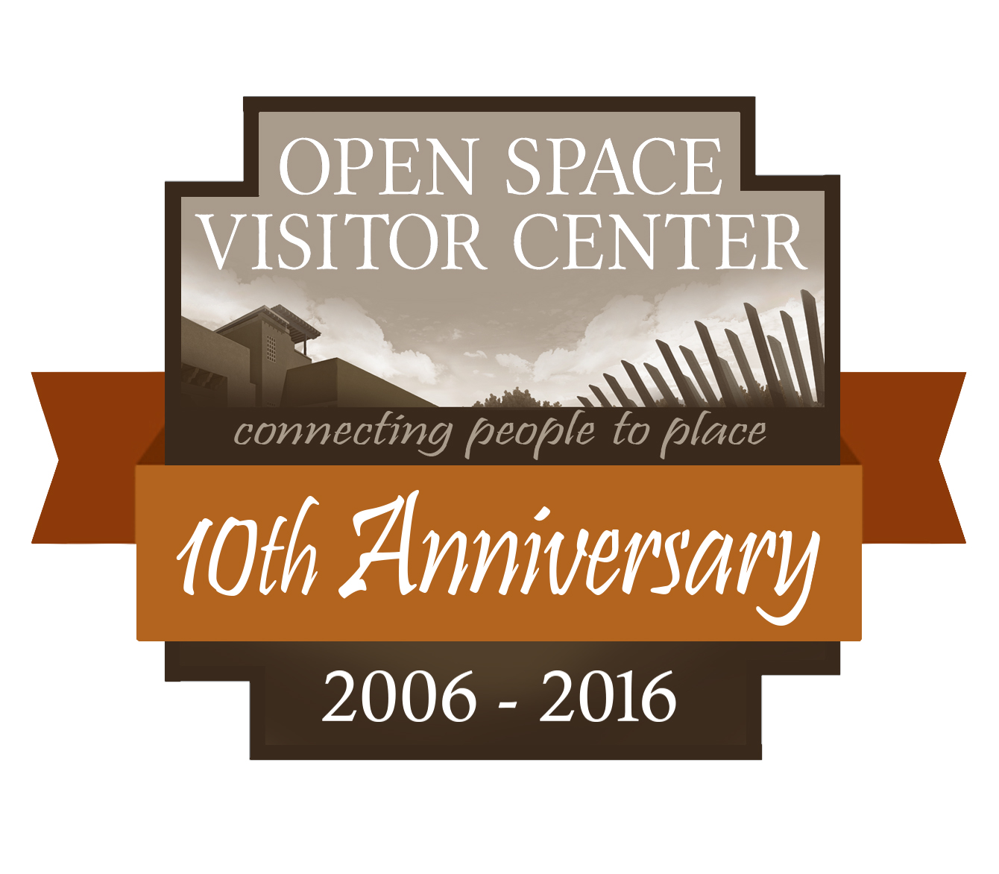
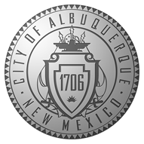
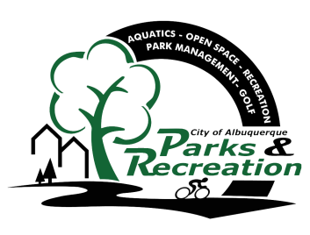
FOR IMMEDIATE RELEASE │October 11th, 2016
CONTACTS:
Media contact: Candace Hopkins, 505.382.8721
chopkins@cabq.gov
Onsite contact: Kent Swanson, (505) 897-8831, kswanson@cabq.gov
The City of Albuquerque Parks & Recreation Department and the OPEN SPACE VISITOR CENTER present
New Mexico Film Premiere of Bison Nation: Walking Sacred Sites
WHO: The general public of all ages. Please bring your own lawn chairs / blankets.
WHAT: Film screening of a newly released documentary from award-winning filmmaker Elke Duerr. Enjoy the movie from our outdoor patio!
WHERE: Open Space Visitor Center | 6500 Coors Blvd NW at the end of Bosque Meadows Rd. between
Montaño and Paseo del Norte.
WHEN: October 29th, 2016 | 6:00 pm to 8:00 pm. Films runs 1 hour, ten minutes
INSTRUCTIONS: Admission is a suggested “pay what you can” donation. All proceeds will benefit the Open Space Alliance and the Web of Life Foundation.

From the Award-winning director Elke Duerr, comes Bison Nation: Walking Sacred Sites. The first opportunity to view this film in New Mexico will be outdoors, under the stars at the stunning Open Space Visitor Center in celebration of its tenth anniversary.
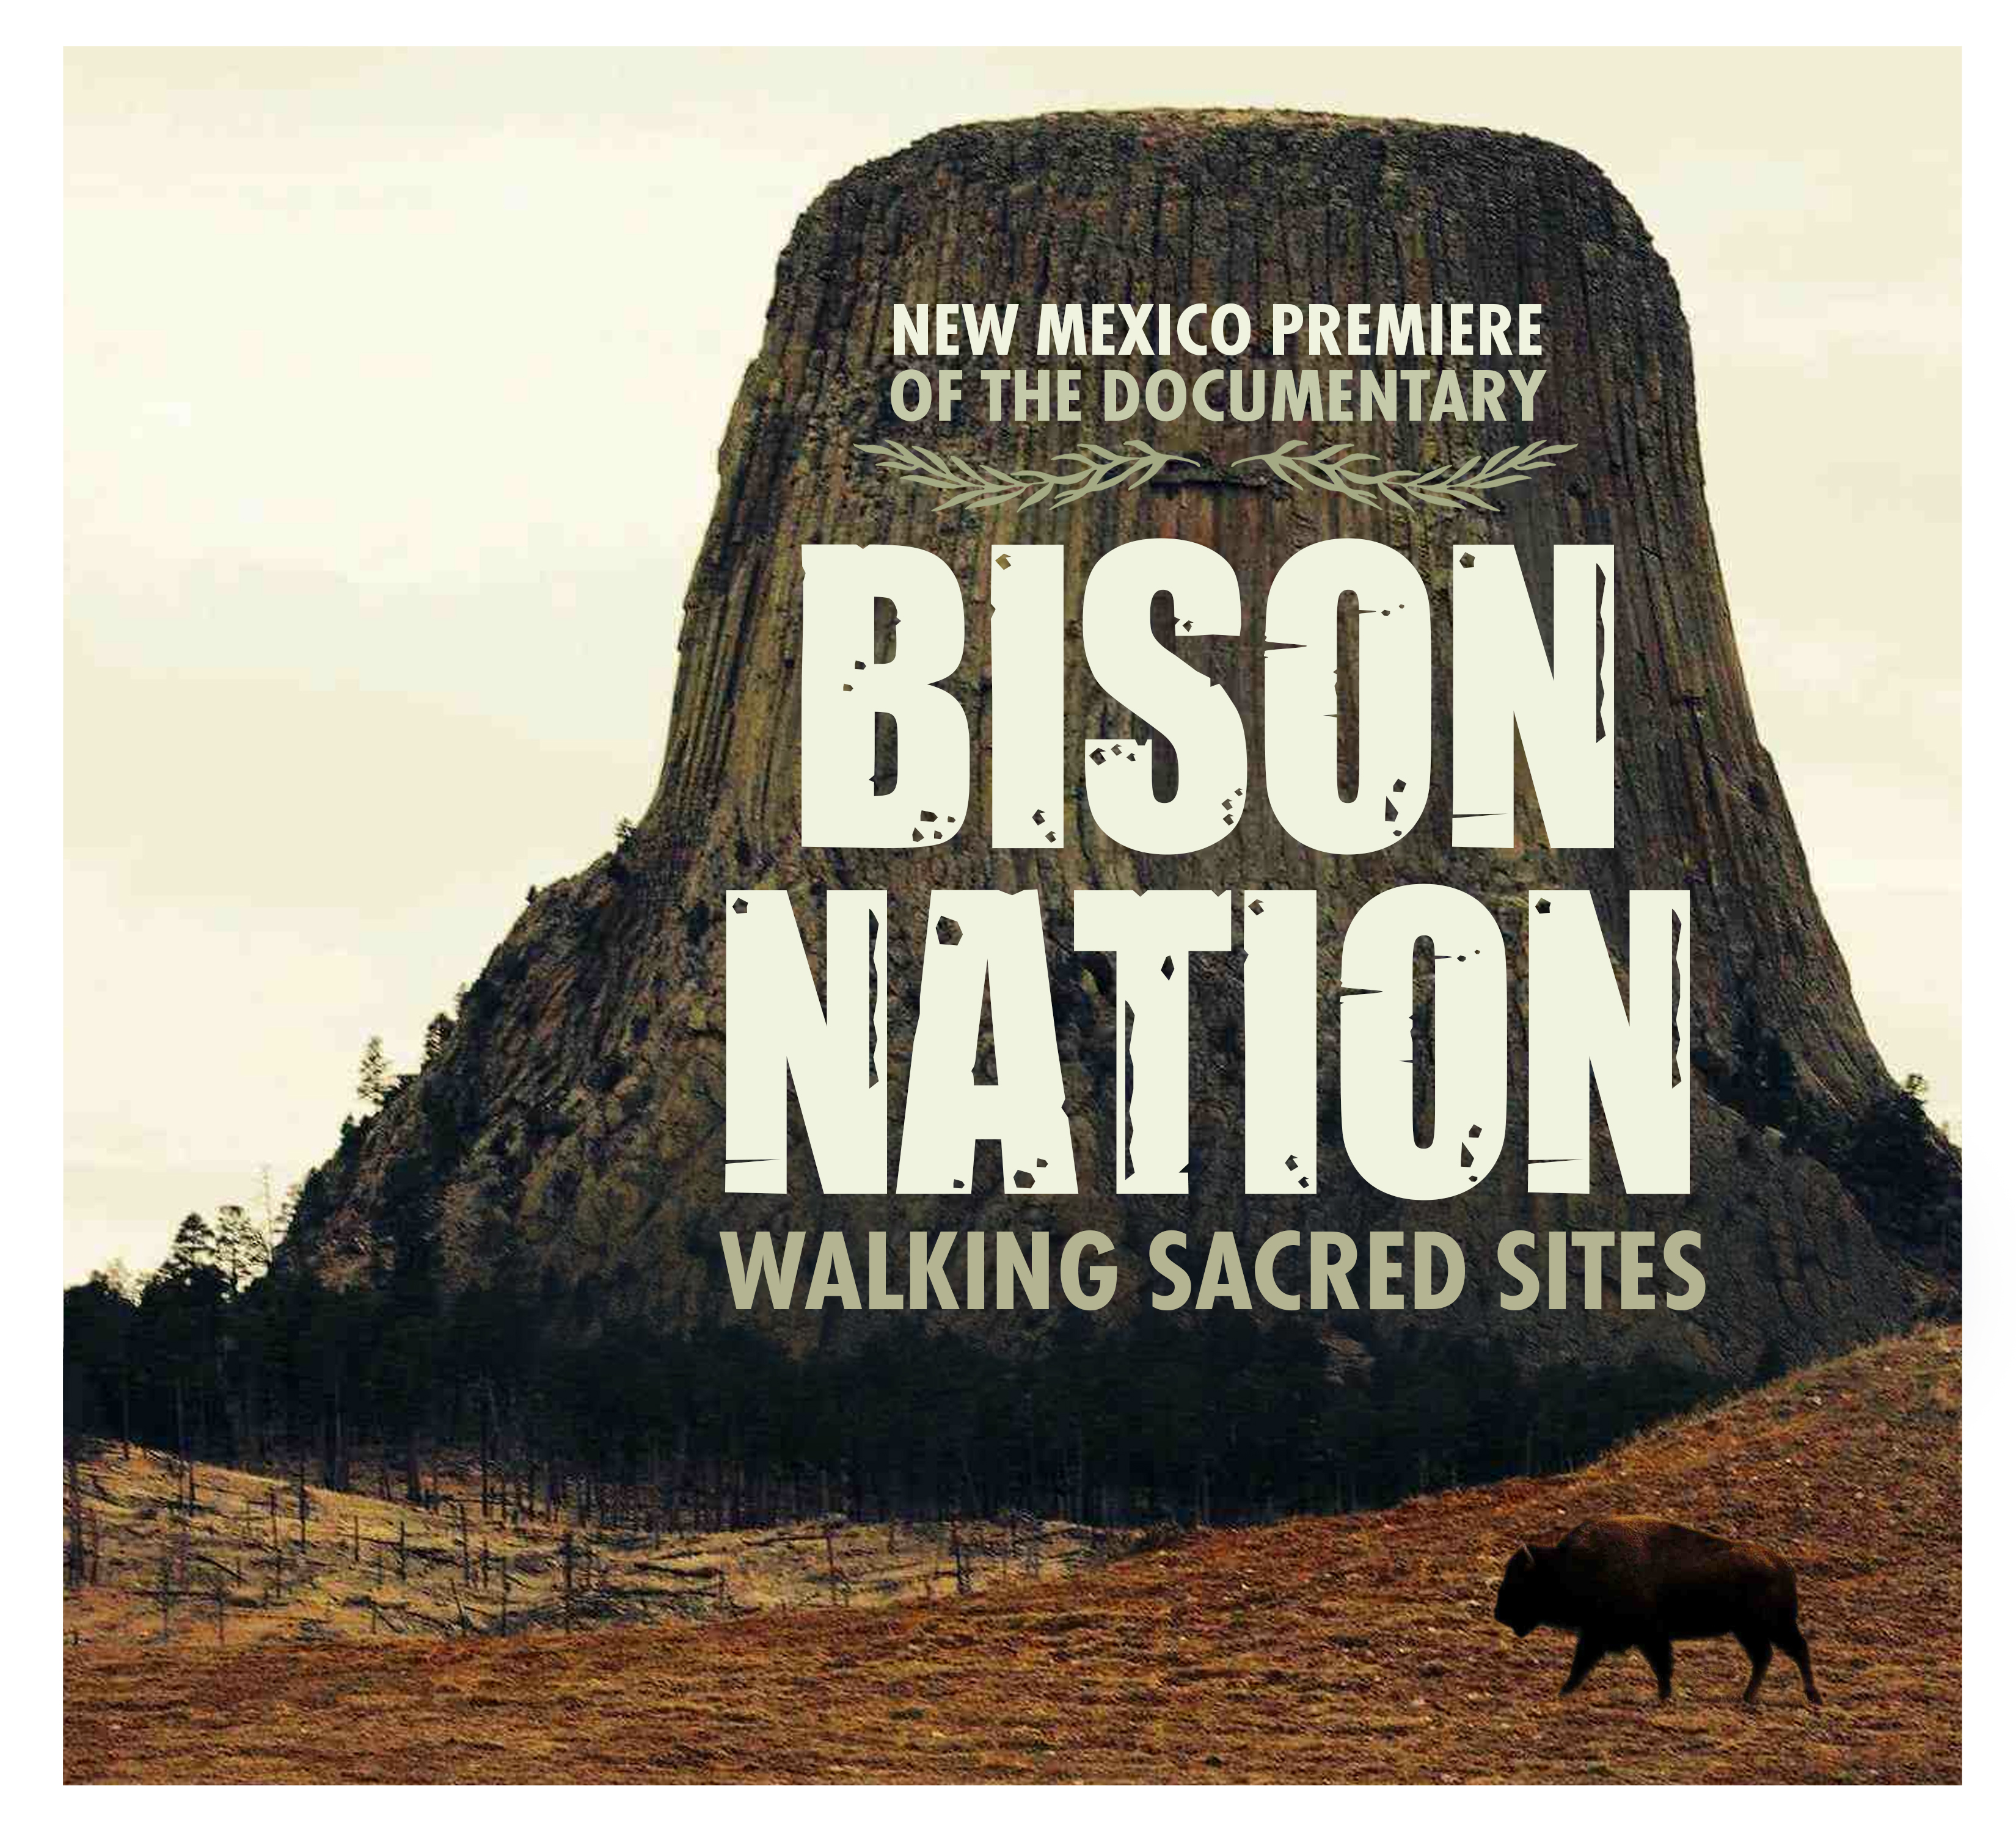
- Introduction and Blessing by Peggy Wellknownbuffalo from the Crow Nation & Director Elke Duerr
- Buffalo Dance by Jim Red Eagle of the
Nakota/Dakota/Lakota Nation
- Screening of Bison Nation, 70 minutes
- Q & A with the director, book signing

We are still here. This is our story, the story of the bison, who inhabit the Northern Hemisphere. You might also know us as buffalo, tatanka, zubr, wisent, basha, Inii, ethanon, tatanga, It is a comical story, because sometimes we are caught in politics, colonialism or religion. It is a story of disconnection and destruction as well as a story of hope, resilience, beauty, interconnectedness, return and reunion. We are walking sacred sites because we take care of our biggest sacred site: The Earth.

Elke is a filmmaker, conservationist and teacher and the founder and director of the nonprofit Web of Life Foundation W.O.L.F. Her favorite classes are with children as she loves to debunk myths and preconceived notions about our animals and natural world and revolutionize the way we see and experience nature.

Her full-length documentary “Stories of Wolves-The Lobo returns” premiered in Santa Fe, New Mexico in October of 2011. She is the recent recipient of four awards for this film: Los Angeles Independent Film Festival Awards Stories of Wolves Documentary Feature Jury Mention, Hollywood Independent Documentary Awards Stories of Wolves Feature Winner, Hollywood Independent Documentary Awards Woman Filmmaker Feature Winner, and International Independent Film Awards Documentary Feature Silver Winner 2016.

The Open Space Visitor Center is located at 6500 Coors Blvd. NW between Montaño Rd. and Paseo del Norte at the end of Bosque Meadows Rd. The Center is open Tuesday through Sunday, 9:00 AM – 5:00 PM and closed Mondays. Call 897-8831 for more information or visit www.cabq.gov/openspace.
####

